**PARUL UNIVERSITY**

**Parul Institute of Computer Application**

**Basic Software Engineering – 05101253/05301253**

**Semester -4**

**Case Study Example: Online Library System (OLS)**

**Practical 1:** Identify Project Scope & Objective

**Identify Project Scope & Objective:**

* Online Library System (OLS) Provide an interface for Read online books for User according to their interest.
* Online Library System can be used by any user from any country who wants love to read to books.
* Online Library System having all kind of books like fictional, novel, etc.
* One Important thing first user have to register in the System. It will provide the System with fake user.
* For use Online Library System user have to first register and, in the system, then he can choose the type of book he wants to read then the available books will be shown and then user can read.
* User having also an option like if they want then they can review about the books.
* Revies and comments can improve system features and it also help to fix bugs from the system.
* **Let’s understand with a simple example:**
* Let a User want to read a Novel name The Diary of a Young Girl by Anne Frank, so first user have to login the system if he/she is already registered in the system then he/she will go the Novel section and then He can search The Diary of a Young Girl and now he/she can enjoy the Book.
* System is totally free to use, no amount of money should user have to pay to read books, User can’t download books.

**Modules & its descriptions:**

**1. Login Module**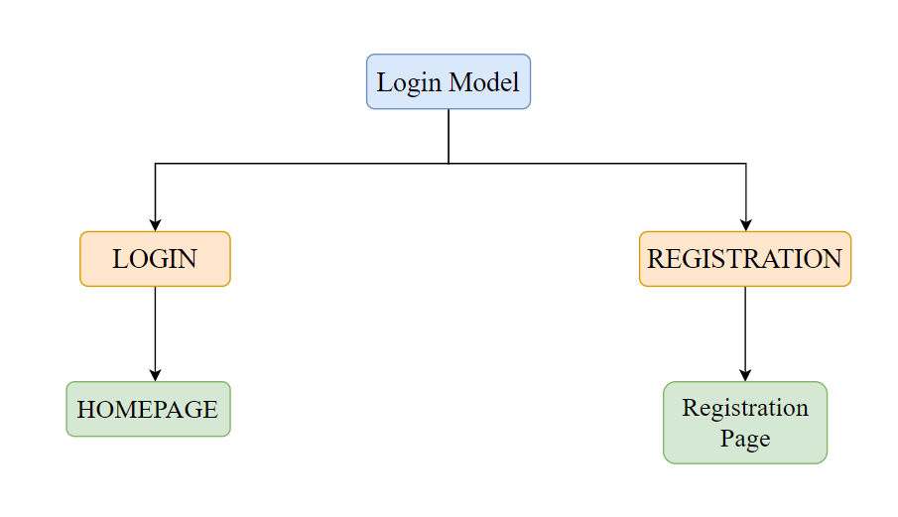

**Login:** This module enables user to Login or Register in the System.

**These are the sub modules of Login (main module)**

* 1. **Login:** Registered user can only login in the System.
  2. **Register:** Any user can Register in the System.

When Login module is executed then homepage will open and when Registration module is executed then Registration Page is executed.

* 1. **Login > Homepage:** After completing login it will go to the Homepage where user can choose the type of book that he/she want to read.
  2. **Registration > Registration Page:** After Clicking on Registration, it will be redirected on Registration Page.